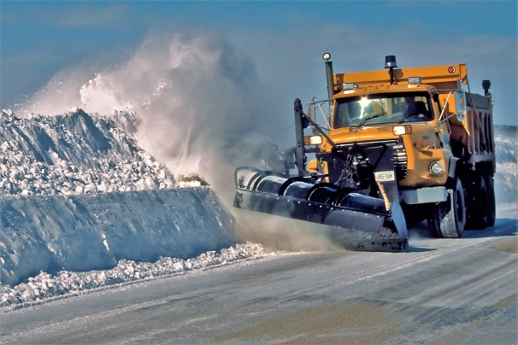

Our current snow removal company is LandTech (LT).

Please note that while it is snowing LT will first clear all the roadways and if necessary the steps and ramps. If they have to return because the snow has not stopped they will.

Once the snow stops, LT will clean all the parking spaces and re-clean the roadways, steps, ramps and sidewalks.

Currently the snow is dumped in the round in front of 6532. LT must remove the snow within 48 hours.

While waiting for the snow to stop or once it has stopped there are a few considerate ways to remove the snow from your vehicle:

1. If you back-in your vehicle, just clean your front window and drive your vehicle into the roadway. If you drive-in your vehicle, clean off the front and back windows and back your vehicle into the roadway. Once you are in the roadway, clean the remaining snow off your car. This ensures the snow you are removing is not being dumped between your car and your neighbour’s vehicle. If LT has to make a second clean-up run, the snow will be removed from the roadway.
2. Should you decide not to move your vehicle from your parking spot when you clean-off your car, we would ask that you shovel between your vehicle and your neighbour’s vehicle.
3. If your vehicle has been parked for a lengthy period of time and you do not move your vehicle, we would also ask that you shovel between your car and your neighbour’s vehicle. The snow plow can only get so close to the cars and it makes getting in and out of the vehicles hazardous.

Should you have any further questions please do not hesitate to call Monica Murad at   
613-742-5778 ext. 239 or email her at [monica@pmamanagement.com](mailto:monica@pmamanagement.com)

Thank you for your co-operation in this matter.  
CCC 316 Board of Directors